Mission in South Sudan

September 1, 2014

Dear friends and supporters,
It is a pleasure to report God’s continued blessings on the Southern Sudan Mission. If you recall from the August newsletter, we had a special personal evangelism class for twelve select students with the goal of locating them in the two new Sudanese Refugee Camps near our compound in Gambella, Ethiopia.
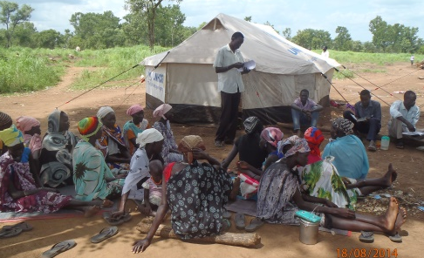
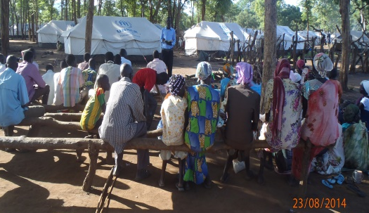
In a recent email, James Puot, the brother that heads up the work in my absence wrote, “Students have been located in both camps, Itang and Leptior, Ethiopa as well as some located in Feugnido, an older camp. There are many individual evangelism classes being taught daily. Chan, Gatluck and others are continuing the follow-up work with the parents of the students from our recent successful Vacation Bible School.”
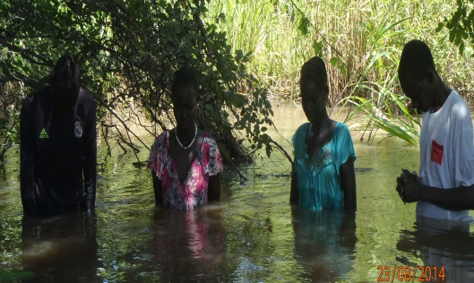
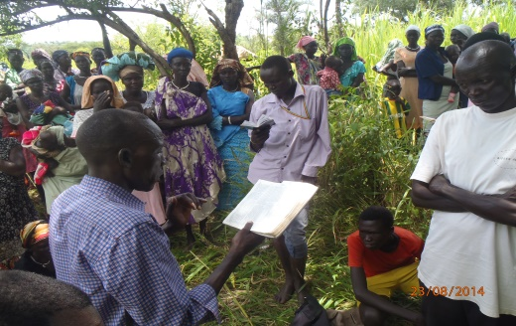
God continues to bless these efforts with additions. Sunday, August 24th, 50 were
baptized in Itang, forty three women and seven men. Praise God for the power of His Word that pierces hearts and calls people to obedience (2 Thessalonians 2:14).
With the realization that windows open and close quickly, we will keep as many evangelists in the refugee camps as possible. In time, some of the refugees will return to their home land and spread the gospel to their people while others will remain in the Ethiopian Refugee Camps. Temporary meeting facilities are being erected at the refugee camps as time and finances permit.
I will be returning to Gambella on Sunday, September 21st to work with and encourage the brethren. We will also discuss plans for 2015 including continued work in the refugee camps, Sudanese School of Biblical Studies and Vacation Bible School. We will also discuss plans to start an Ethiopian Congregation in Gambella and hopefully use the new facilities for an Ethiopian School of Biblical Studies. I will continue on to Bor, South Sudan, to teach new converts. Please keep these efforts in your prayers.
Sister Rusty Holland, of Porter Church of Christ, a 2013 and 2014 Vacation Bible School teacher will also return to Gambella on Sunday, September 21st. She will stay on the compound in Gambella until December 16th. Rusty will work with Chan teaching the children and will teach the older women to be teachers. Please keep Rusty and her work in your prayers.
We are in urgent need of financial support for the guest house and to continue these and other evangelistic efforts in Gambella, Ethiopia and South Sudan. If you can help, please make your tax deductible checks to Woodland Oaks Church of Christ ear-marked Gambella Construction Fund and mail the same to Tyrone Mynhier and I will record the gifts for my records and forward them to Woodland Oaks. Thanks for your trust and continued partnership in the gospel. Phil. 1:3-5.
-Tyrone Mynhier
Mark your calendars. We are planning a South Sudan Mission Forum November 14, 2014. We will contact you when plans are finalized.

