SOUTHERN SUDAN MISSION
532 Raleigh Dr.
Conroe, Texas 77302
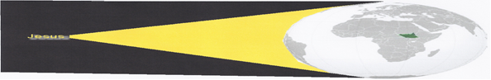
SHINING THE “LIGHT” INTO SOUTH SUDAN
October 27, 2016

Dear Friends and Supporters of the Southern Sudan Mission,
Thank you for your continued love, prayers, encouragement and partnership in the furtherance of the gospel in South Sudan and the world.
Over the years I have used this newsletter to write of a special event or individual that impacted the Southern Sudan Mission. Today, I think it is time to introduce you to those who have been very instrumental in the success of the Southern Sudan Mission – the fearless, valiant warriors and teachers of the first (2013) through the fourth (2016) Vacation Bible Schools in Ethiopia (probably the only VBS in Africa).

If you recall from former newsletters, in 2008 I was asked to teach Sudanese Refugees in the Ethiopian/Sunset International Bible Institute School of Preaching in Addis Ababa, Ethiopia. In 2011, I became the director of the South Sudanese Refugee work and, with the help of a few others, relocated the headquarters to Gambella, Ethiopia, a city with approximately sixty-five thousand people (half Ethiopian and half South Sudanese Refugees). The mission was named “Southern Sudan Mission” and the School named “Gambella/South Sudanese School of Biblical Studies”. Reasons for relocating the work included the following: The Sudanese students required transportation from Gambella to Addis Ababa, Ethiopia (4 days travel); all Sudanese Refugee Camps were located near Gambella, Ethiopia; the Sudanese have open access to the Ethiopia-South Sudan border; and Gambella provided Ethiopian protection from warfare in South Sudan.

The Lord blessed the mission and many conversions were held within a few months causing some leaders of other religious groups to approach James Puot, the Director of the School of Biblical Studies, requesting we stop teaching the Bible. Many of their members obeyed the gospel and began attending our assemblies. James responded with, “In the church of Christ we only teach God’s Word, the Bible, and people make their own decision about obedience and where to attend an assembly. No! We will never cease teaching God’s Word.” Acts 5:29

James’s response did not meet the religious leaders’ approval causing them to forbid their members to study or associate with anyone from the Church of Christ. The religious leaders began stirring up people against the Lord’s Church stating, “The Church of Christ is only for young men.” “The Church of Christ is a dangerous cult.” “If the Church of Christ is the true church why have we not heard of it until recently?”, etc. Additionally, they made false accusations and even threats against James and me.

On my returning flight home in early January 2013, I brainstormed the best way to expose and expand the church of our Lord when an idea entered my mind – Vacation Bible School. I kept the thought to myself praying over it. Later, I mentioned the thought to my wife, Alma, who agreed it was a great idea. Unfortunately, she knew she would not be able to help as she recently received a pace maker.

After constant prayer and consideration, it was determined we should attempt to have a VBS. Where to go from here? I visited with Ken Stegall, the preacher at Woodland Oaks Church of Christ, and we discussed who might help with such an endeavor? Ken recalled, Joanie Roberts recently attending a mission trip to Benin and suggested reaching out to her since she was also retired.

I met with Joanie and explained my vision, as well as the possible dangers of working in Gambella, Ethiopia, only to receive her response, “Yes! I will help.” The trip was planned; however, Joanie only gained one committed recruit – a young college student, Karisa Holland. As the departure date neared, Joanie and I questioned if we should cancel the trip due to lack of teachers. I approached a sister from Porter Church of Christ, who attended some stateside mission trips with Alma, and she agreed to go. One more teacher would make it ideal.

Alma had a doctor’s appointment to check her pacemaker and a wonderful report. He said, “You are doing great and can do whatever you want!” “Go to Ethiopia on a mission trip?” I asked. The doctor looked at Alma and asked, “Do you want to go to Ethiopia?” Alma said, “Yes.” Hallelujah! The 2013, mission trip is on, and we will have 100 students.
Alma, Rusty, Karisa, Joanie

In 2014, Joanie planned to lead the VBS again; unfortunately, a few days before departure, she became sick and was unable to travel. However, three other women and one gentleman, Renee’ Cloud, Kim Province, Katy Reaves and Brother Bryce Caldwell, joined the VBS Team to teach 200 students.

In 2015, the doctor told Alma it was unwise to continue traveling to Ethiopia due to lack of qualitfied doctors to help with her pacemaker if she were to encounter a problem. Despite this news, the Lord provided again. Bryce Caldwell agreed to direct VBS and received commitments from Karisa, Renee, Rusty, as well as Nathan Lockwood, Zachary Conrad and Kaelynn Prichard to teach what had grown to 500 students.

In 2016, Bryce again directed VBS accompanied by Karisa, Kaelynn, Nathan, and new comers, Sarah Mayo and Tanner Gibson (500 students taught again). Unfortunately, every year more than 100 desirous students are turned away due to our small number of teachers.
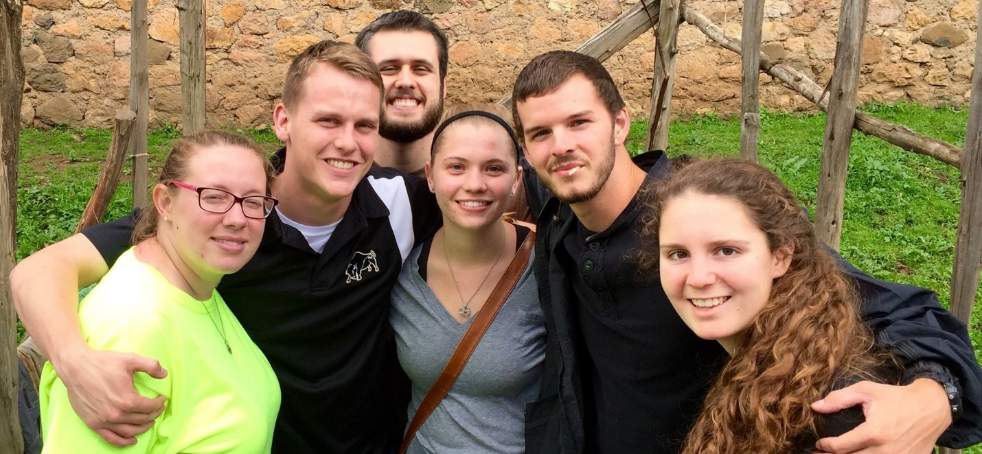
2016 VBS Teachers (L to R): Kaelynn Prichard, Nathan Lockwood, Bryce Caldwell, Karisa Holland, Tanner Gibson, Sarah Mayo
One thing making the Southern Sudan Mission a unique stand-alone mission is the blessing of many different Christians participating in the work. We have had thirteen VBS teachers through the years, been blessed with help from Brother David Roberts and Brother Lou Eich, received meals for benefit banquets from Sarah Blake and her crew, and constantly receive love, prayers encouragement, and financial support from the Woodland Oaks Church of Christ Family. This has truly developed into a Woodland Oaks Mission and I thank you. Through our work in Ethiopia, I only hope and pray those involved and exposed to the ministry are encouraged to continue being evangelistic wherever they call home.
If you feel called to support our mission financially, please make your tax-deductible contribution payable to Woodland Oaks Church of Christ, ear-marked Sudan Mission, and mail the same to Tyrone Mynhier, 532 Raleigh Dr., Conroe, Texas 77302, for posting and delivery to Woodland Oaks Church of Christ.
“To Him be the glory in the church and in Christ Jesus throughout all generations, forever and ever! Amen.” Ephesians 3:21 (NIV)
Tyrone Mynhier

PLEASE MARK YOU CALANDERS
Next Friday

SOUTHERN SUDAN MISSION BANQUET
Friday, November 4, 2016
6:30-9:00 PM
Woodland Oaks Church of Christ
7300 Crownbridge Drive
The Woodlands, TX 77382

EVERYONE WELCOME
If you know someone that might be interested in the mission,
please invite them to the banquet

P.S. The date of the 2017 VBS is July 3rd – 7th. Will depart the states Friday, June 30th, and return home Sunday, July 9th. Our goal is to teach 1500 children. WE NEED 12-14 TEACHERS! If you are interested, please contact Bryce Caldwell caldwellbry@yahoo.com or Tyrone Mynhier southernsudanmission@gmail.com. Thank you.

