Mission in South Sudan

May 5, 2015
Dear friends and supporters of the Mission in South Sudan,
I pray God’s rich blessing be upon you! In January 2011 when we moved the School of Biblical Studies to Gambella, a middle aged Sudanese woman, Mary, visited the School. Her interest was kindled and she asked if she could audit the classes and was permitted to do so. After several weeks she asked if she could visit with me. As we visited she said, “My husband is the preacher at one of the Anglican churches in Gambella, but after auditing several classes I realize the teachings of the Anglican Church is not consistent with the Bible”. She continued, “Could I continue to audit classes?” Of course we permitted her to do so. After a few weeks she said, “I would like to obey the gospel and attend worship services with you, but I am afraid if I do my husband will be terminated from his preaching job”. I asked her if she thought her husband would study the Bible with me privately. When she ask her husband he rebuked her and told her to stay away from me and that new school of false teachers.
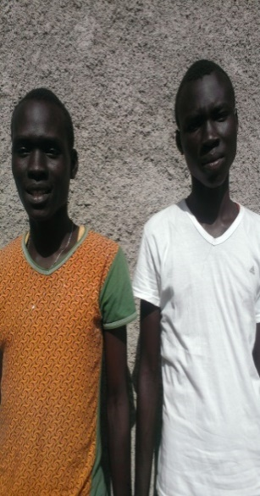
After my departure to the states, Mary frequently asked James Puot, the preacher at the Gambella Church, when I was going to return to Gambella. The next time I returned Mary came to visit me. I could tell she was deeply troubled as she began talking. Again she stated, “I know the things you taught were from the Bible and are true. I want to obey the gospel, but I fear if I do my husband will lose his preaching job. My husband is angry and told to stay away from Tyrone and that school that teaches false teachings or he might lose his preaching job,” She continued, “I have two sons, Muoch and Boay, I would like for them to attend the school if you would permit them to.” I assured her that would be great. After a few weeks of classes her sons obeyed the gospel (Mark 16:15-16). Mary came to me and expressed her appreciation that her sons had heard the truth and had obeyed the gospel. She said, “I still cannot obey the gospel, but my sons and I will talk to my husband about attending the classes if you will permit him too”. I told her to tell her husband he was welcome to attend if he desired too. Unfortunately, her husband would never meet with me or attend classes.
Mary’s sons were high school students when they were converted. They were very zealous working and teaching others about Jesus. They are both in college now and remain very active in the church. Boay is a very good preacher and is as an assistant in the Fugindo Sudanese Refugee Camp Church located about two hours from Gambella.
Tuesday, April 28, Muoch and Boay came to visit me in Gambella. They told me their father passed away Sunday, April 26, and was buried that day. They said an official of the Anglican Church talked with them at the funeral and told them the Church of Christ was wrong and they should give it up and come and work with the congregation their father had preached at. They, in return, told the Anglican Official they could not be a part of the Anglican church because their teachings were not in accordance with the Bible. The Anglican Official chastised them and sent them away.
Unfortunately, Mary’s husband had persuaded her to continue worshipping at the Anglican church where he preached; however, Muoch and Boay said they would try to study the Bible with their mother again and hopefully she would obey the gospel. Both boys are committed to helping further the gospel among the Nuer South Sudanese People. Please keep these two committed gospel preachers in your prayers and pray Mary will once again see the truth of the gospel and be obedient to its call.
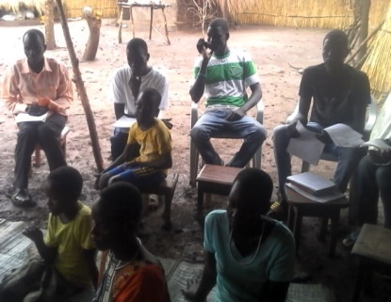
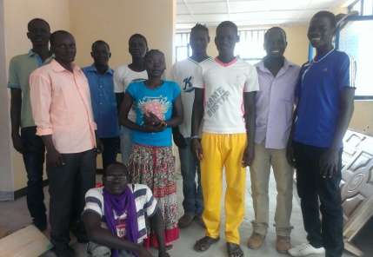
More good news from Brother Okello Obang about the Anywaa church. The number of adult Christians is now 23. Several children attend as well. Additionally, Brother Okello brought several Anywaa People from Abol Town, an Anywaa community about 15 miles from Gambella, to study the Bible with me. After several hours of study, three young men were baptized into Christ (Galatians 3:26-27) and added to the Lord’s church (Acts 2:47). One of the new Christians, Lual Otin, a college graduate and a NGO in Abol Town requested the opportunity to continue studying because he wanted to be able to teach his relatives and friends. Everyone stayed and we studied two additional days. At the conclusion of the studies Brother Lual said he wanted to start a church in his home. Please note the picture of the first meeting of the Abol church in Lual’s yard. Okello sent the picture and the following email:
“Dear brother, this morning, we were worshipping at Abol Town Church of Christ and the attendance was 10.”
Yours in Christ,
Okello

Okello will travel to Abol Town to find a meeting location and help the brethren for a few weeks. Two new converts from the newly founded Pwoljay church will preach in Okello’s absence. (The three converts also requested the opportunity to attend the next School of Biblical Studies classes). Please remember the Anywaa work in your prayers.
We also made the final plans for this year’s VBS and the School of Biblical Studies. Brother Bryce Caldwell will direct one VBS for 300 Nuer Sudanese Children and another VBS for 200 Anywaa Sudanese Children. Several members from Woodland Oaks will assist Bryce including Zachary Conrad, Nathan Lockwood, Karisa Holland and Kaelynn Prichard. Please pray for these brethren as they prepare to go teach the good news. (We still need a couple of teachers. If you are interested, contact Bryce Caldwell or Tyrone Mynhier).
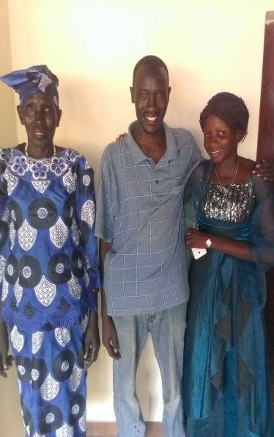
David Thoatmer is very active in the work. He has taken the responsibility of being the located preacher at Gambella. I had the opportunity to meet his mother and wife and thought you would enjoy meeting them also.
I want to extend a special thanks to Dave Roberts for traveling with me to help make the guest house ready for visitors.
The Lord continues to bless the South Sudan Mission abundantly with numerical and spiritual growth. Be assured every supporter of the work though prayer, encouragement, and/or financial support is as much a part of the success as those who are privileged to personally go. You are deeply appreciated. Thank you for your continued partnership in the furtherance of the gospel into South Sudan and the world.
Tax deductible contributions may be made payable to Woodland Oaks Church of Christ, ear-marked Southern Sudan Mission and mailed to Tyrone Mynhier for posting to Woodland Oaks.
Thanks again for your prayers, words of encouragement and financial support of this great English speaking evangelistic opportunity. I pray we will always be worthy of your trust.
In Him,
Tyrone Mynhier

