SOUTHERN SUDAN MISSION 532 Raleigh Dr. Conroe, Texas 77302

March 26, 2018
Dear friends and supporters of the Southern Sudan Mission,
Our hearts over flowed with joy and excitement as God blessed the Southern Sudan Mission with electrically pumped, pure, clean water from the well we drilled in early 2017.
If you recall in late 2016, a special little girl, Lainey Lee, was asked by her parents, Brian & Nikki Lee, what she would like to give a child in a foreign country for Christmas. As she and her parents looked at pictures from different books searching for the right gift, they came to a picture of a water-well. Lainey asked about the water-well. Upon her parents explaining a water-well could provide clean water for people to drink, Laine said, “I want to give a water-well to the children in a foreign country so they can have clean water to drink.”
Lainey’s parents explained to her, a water well would cost thousands of dollars and would be too expensive, but Lainey insisted she wanted a water-well for the children so they could have clean, pure water to drink. After much discussion Nikki made a few phone calls to other parents and a decision was made to give a water-well. Nikki called me (Tyrone) and questioned about the need for a water-well to provide South Sudanese Refugees clean water to drink. I told Nikki that the mission team and the Sudanese Brethren had been praying for a water-well. Nikki told me of Lainey’s wish and her discussing the wish with other families who thought it was a great idea and also wanted to help raise the money to drill a water-well. Of course I excitedly said, “That would be great!”
Within a few hours the water-well became a spiritual family project. The parents explained the opportunity to their children and they worked together to make the dream a reality having cookie sales, lemonade stands, garage sales, etc. Within a few weeks the children and their families raised $10,000.00 for the water-well.
Unfortunately when I returned to the states I told Nikki, the well would cost $15,000.00. Nikki said, “We have exhausted all our means in raising the $10,000.00 and I am not sure we can raise an additional $5,000.00. The next day Nikki called and said, “An individual gave the additional $5,000.00 needed for the well.”
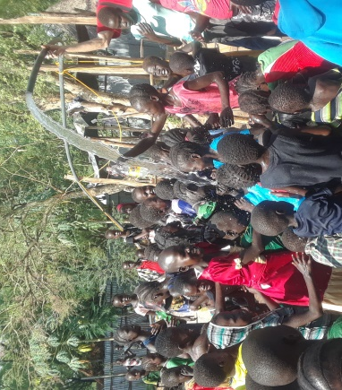
In February of 2017 the well was drilled, but the driller suggested we get an American made electric pump as the quality of the pumps in that part of the world were not very good. I was able to get a pump with the help of Brother Flow Mata, an elder from Woodland Oaks. I took the pump to Gambella in June, but the United Nations had employed the driller and there was no one to install it.
Brother Jim Chandler, an elder from Partellas, New Mexico was scheduled to go with me in August to teach in the school and also install the pump. As most of you know, the day Jim and I were to depart for Gambella, Hurricane Harvey hit Houston and my house was flooded and all flights were cancelled for several days.
In March, 2018, Brother Jim traveled with me to Gambella to teach in the School of Biblical Studies.
There were also expectations of installing the pump. Saturday morning Jim and all the students began putting the pump in the well and within a few hours the work was completed.
Jim connected the electricity to the pump and March 17, 2018, Lainey’s dream was fulfilled. The pump began pumping 40 to 50 gallons of pure and clean water a minute.
The students and others watched in amazement as the water began to flow. They had never seen a well of this nature. After the Sunday morning assembly we invited everyone in the assembly to come to the well. Brother Jim held the casing in the air and when Brother James flipped the switch and the water started shooting into the air, everyone was ecstatic. I wish Lainey, every child and every parent that helped make the water-well a reality could have seen the excitement and heard the comments. The children started singing about the well and about the children in America. Many adults expressed their thanksgiving to the children in America.
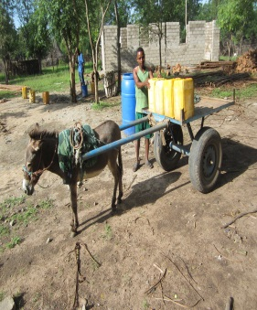
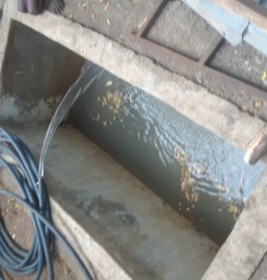
As great as the blessing of the pure clean water to drink is, there is a greater blessing. Since there is no water at the refugee camps most of the people that are baptized for remission of sin come to the compound to be baptized. This is a timely and difficult task. When a leader calls James and tells him they are bringing people to the compound to be baptized, James has to call the donkey man, a person who brings river water to the compound, to fill the baptistery. The donkey man has to make three trips to the river to fill his 15 containers of water to get enough water to baptize. This process generally takes 4 to 6 hours and most people have to sit and wait a few hours to be baptized. The same amount of water can be obtained from the water well in 5 minutes.
The pure clean water a five year old Lainey, her parents, her little friends and their parents wanted for the children to drink has become the water that provides and will continue to provide a means for people to receive “Living Water,” as they are baptized into Christ. Romans 6:1-6; Galatians 3:26-27
As mentioned earlier Jim and I traveled to Gambella to teach some introductory classes to new converts that were preaching in their newly seeded congregations. Unfortunately 8 students that were to attend the classes could not attend, as some warriors from the Dinka Tribe, the South Sudanese Tribe that started the tribal war in December 2013 and continues the same, attacked their village and everyone had to flee to the bush (forest) for safety. Fortunately 17 students were able to attend the school. At our departure we had not received word from any of the brethren in the bush and consequently still do not know if any were injured or killed. Please keep these brethren in your prayers.
James Puot, the Director of the Mission in my absence, other leading brethren and I discussed the plans for the 2018 Vacation Bible School. Pending the approval of Bryce Caldwell, the director of the VBS and the availability of teachers, the team will teach 1,800 South Sudanese refugee children in July. If you would like additional information about teaching in the VBS this year, please contact Bryce Caldwell, 870-421-6594 or caldwellbry@yahoo.com or Tyrone Mynhier, 281-389-7780 or southernsudanmission@gmail.com
Thank you for your partnership with us in the furtherance of the gospel into the world’s newest nation, South Sudan. We solicit your continued prayers, encouragement and financial support.
Tax deductible contribution may be made payable to Woodland Oaks Church of Christ.
Because of Calvary,
Tyrone Mynhier

