Mission in South Sudan
March 26, 2014

Dear friends and supporters,
I pray you are lavishing in the marvelous grace of our Lord and Savior Jesus Christ.

As I write this letter there is a peace keeping force in Nisar, South Sudan and brethren in that area are trying to put their lives back together. Many were displaced in United Nation Refugee Camps or hidden in the bush for weeks as result of warfare.

While the rebels were in the region they destroyed and/or looted most of the huts, houses, and all the stores in the region except two in Nisar. Food and commodities are presently available, of course at elevated prices. The only other source of food is in Martar, Ethiopia, a one day trip by bus in Ethiopia plus a one day trip by riverboat in South Sudan which is exposed to the rebels.

The Lord blessed the brethren from Malakal, South Sudan to make a 30 day trek through the bush to be with the brethren in Nisar. I understand that there are animals, berries, leaves, etc for survival. Some arrived in Nisar with serious health issues, but are improving.

The number of family heads in Nisar are 35 and the number of brethren are approximately 175. Other brethren made their way to our compound in Gambella, Ethiopia and are living in and around the compound with brethren.

The need for food for the brethren has increased considerably and will continue until the warfare ceases. Please prayerfully consider helping as much as possible. Every dollar given to this effort will be used to purchase food and commodities for the brethren. We are blessed to have faithful brethren in Gambella that have been and will continue to travel to Nisar to purchase and disperse food to the hungry brethren.

Please note a few emails from the brethren in Gambella regarding the above stated situation.

to Tyrone |  | Mar 3
Nasser Church of Christ food distribution
Report to Missionary, Tyrone Mynhier, South Sudan Mission

You may recall this from last month:
$ 2,500 US Dollars Changed into Ethiopian Birr = 47,500 Ethiopian Birr
Ethiopian Birr Changed into South Sudan Pounds =14,000 South Sudan Pound

Funds to Nasser for food to aid Church Members meeting in Nasser.
For thirty head families approximately 100 Church Members
Purchased 30 Sacks of corn with each 100kg. Each sack has a cost of
300 South Sudan Pound 9,000
Stew meat, lentils, etc. for 30 3,000
Wagon with donkey transportation to the Church store 324
Total South Sudanese Pounds 12,324
Re balance keep for this time. 1,676 SSP

By then we have new arrival from Malakal who are also in need of food badly. We have some remaining pictures with us to be sent to you on how food distribution start and get into the hand of people who are members of the Lord’s Church over there. Now the number of the people who are worshiping in Nasser is increasing.
About Gambella Church of Christ, we have new arrivals from Nasser and Malakal into Gambella but nowhere to stay, only the Church Compound in Gambella where we don’t know how to get the feeding for them. Only my home and other members home to feed these people. We need some money for these guests from Nasser and Malakal. Every week we have new Visitors in the Church.
Yours
James Pout,Chan ,Jacob,Gatbel. etc

puot nhial

to Tyrone

For your information we receive the money you wired last week, today on 03/03/2014 after we keep going and asking the Bank. Thank for doing this, don’t worry about how we managed them based on programed way. People at Nasser were very excited about what Church of Christ start and follow to give them food in this situation they were in, people from Malakal try to asking us “Where is our share?” and I told them it will come to you soon from Tyrone.
This $4,750 US bring 91,858 Birr .
I think Khor has written to you he arrive in NASSER and his twins boys and their sister were sick on their way to Nasser. He asked the church to pray for him and they are in need of food.
yours
James pout

Malakal Church members
Important mainly because of the people in the conversation.

khorwal dor

to jameskume2000,Tyrone

These are the member family heads names and dependents, for Malakal Church of Christ who have arrived Nasir.
(1) Khor Wal Dor – 8, (2) Johnson Tuach Guet – 7; (3) Kuok Pal Kun – 7; (4) Kun Thichuong Lual – 4; (5) Puoch Ruach Lual – 5; (6) Bil Wal Dor – 5; (7) Nyekang Lual Yiech – 6; (8) Nyakume lual Chiey – 4; (9) Moses Gatwech Thot – 6; (10) Thomas Tut Puol – 9; (11) Tot Nyang Thok – 5; (12) Nyewal Kun Dhol – 7;
(13) Nyibol Kueth Nhial – 4 Total 77
These are 13 head of households and 77 individual. If there will be any new arrival I will let you know.
yours in Christ
Khor Wal
Nasir

Puot nhail
Heartbreaking & unimaginable atrocities!!!! :(
On Mar 24, 2014
"Dennis C." wrote:
Jacob traveled from Bor to Juba on the main road for the first time today. We have traveled this road three times, before any fighting. Other times we have flown. Jacob took another longer but considered to be safer route on his other trip. He describes the trip this way:
"I have safely arrived in Juba. I came thorugh Bor to Juba Road. It's a bit good now and safer only many dead bodies on the road and some at the road side but that's not a major problems. The tank stampeded several people in the middle of the road."
I asked him what "stampleded" meant and he said it looked like the tanks just ran over people. He said there were four damaged tanks that had been deserted. There has been no significant fighting in this area for over a month so I assume these bodies have been there at least that long. I do not know if they are civilian or military. I assume both.

FIRST FOOD DISTRIBUTION TO NISAR SOUTH SUDAN
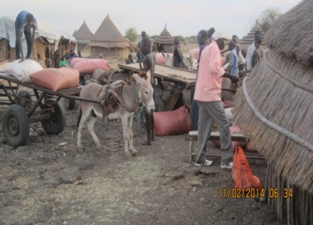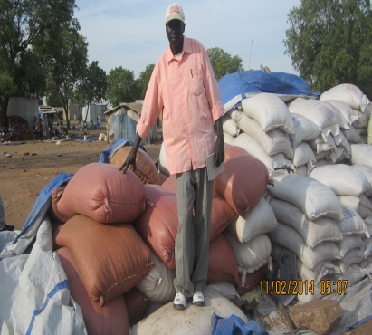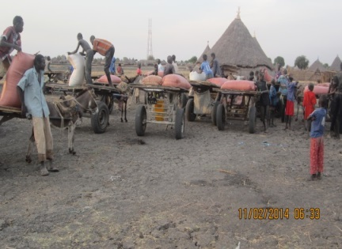
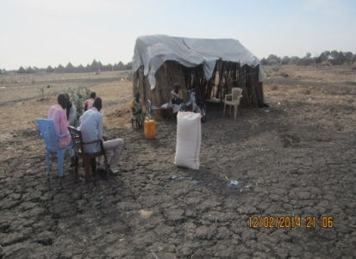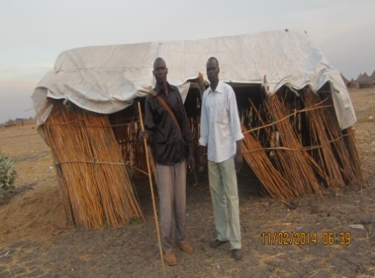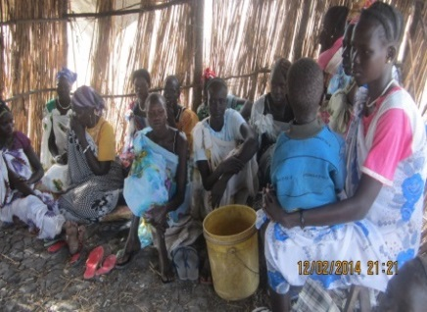
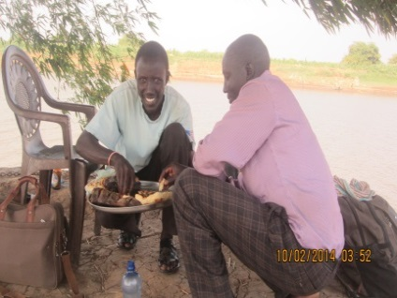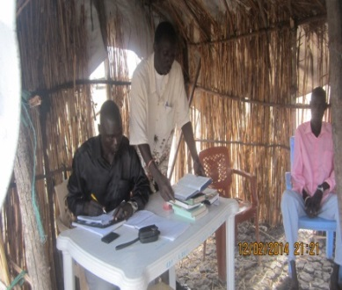
L. Chuol Pal Wal, Nisar Preacher Chan Gatluat & Nisar Members L. Chan Gatluat Gambella Preacher Chan Thoat Pal, Nisar Member R. Kueth Both Cany, Nisar Preacher
SECOND DISTRIBUTION OF FOOD TO NISAR SOUTH SUDAN
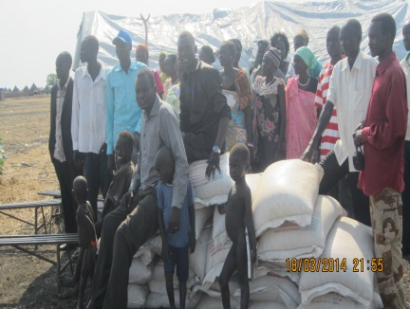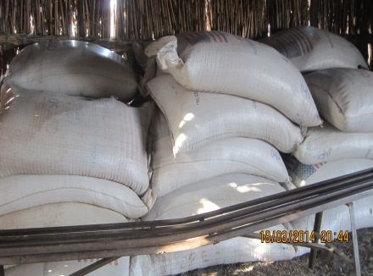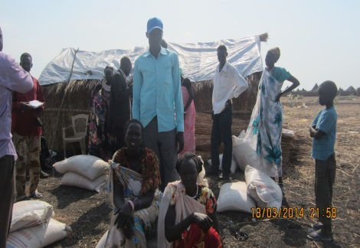

James Pout
to Tyrone

These are the last pictures of Malakal distribution at Nasser area where all church members are staying at this time of war.
Thank you brothers and sisters, this is unexpected from people at Nasser and Malakal to happen like this, because of the love of Jesus it happens to support brethren who are in dire situation.
Now the inhabitants are begging church members to give them some tin of corn for their families to survive, claiming that you are the people of Christ why don’t you save others who are not members since you have the love of Christ in you? Save us, we are your neighbor not in Christ just your love of your people at Nasser, who know we may be part of Christ’s Church tomorrow please save our families lives like you do for yourselves.
This is the end of their happiness message and sad message from inhabitants.
Like you Brother Tyrone said in your letter is true. This is the good opportunity to preach Christ to them. Now at the end of this month when you send the money I will go myself and spend some days in teaching and baptizing people there who will come forward and taking WBS materials with me .
yours
James Pout

As you can see the brethren are very appreciative of our help. It is also evident we can reach non-members with the gospel, if we had funds to help them as well.
Please forward this information to other churches, relatives and/or friends that may have interest. There is no middle man all funds dedicated to this effort will be used to feed and further the gospel in the Upper Nile Region of South Sudan.
TAX DEDUCTIBLE contributions may be made payable to Woodland Oaks Church of Christ, ear-marked South Sudan Mission and mailed to Tyrone Mynhier.

Because of Calvary,

Tyrone Mynhier
President of Gambella-South Sudan School of Biblical Studies, affiliated with Sunset International Bible Institute, Lubbock, Texas.

