SOUTHERN SUDAN MISSION
532 Raleigh Dr.
Conroe, Texas 77302

February 21, 2018
Dear Friends and supporters of the Southern Sudan Mission.
As we are surrounded with constant turmoil, be comforted to know God’s love and His presence with and in us through the personage of the Holy Spirit is greater than any force in the universe that stands against us. “You, dear children, are from God and have overcome them, because the one who is in you is greater than the one who is in the world,” 1 John 4:4.
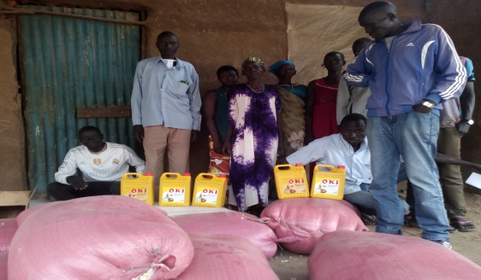
As you know from previous newsletters, on July 9, 2011, South Sudan was freed from North Sudan and the Islamic Religion and became an independent nation. Upon receiving their freedom, a Dinka Tribesmen was appointed President and a Nuer Tribesman was appointed Vice President. Things went seemingly well as the leaders began to restore the ravaged nation. Unfortunately within a few months the two leaders began accusing each other of trying to gain preeminence in the nation. The power struggle continued until December 2013 and escalated to a full grown tribal war forcing many South Sudanese back to refugee camps. Unfortunately, if one does not have proper credentials, record of birth, etc., they cannot be relocated to a refugee camp. For this reason many are forced to live in the bush without food and often water. Even in these destitute situations the church continues to grow. The mission has been feeding many of these brethren for the past several months. The brethren are hopeful they will be able to grow a few crops that should be ready by late March or early April. Unfortunately if the warriors find the fields they will take them. I realize there are many other similar situations around the world, but it makes it seem more important when it is with the people one works with.
Please note the following emails from David Thoatmer and James Puot regarding a few Ethiopian-South Sudan border cities with congregations on both sides of the border.

Jan 20, 2018
“We have other good news from Wanding Church of Christ where John Chuol took some food to help the brothers who were affected by war. John baptized 26 souls into Christ. Many were glad to what our brothers and sisters in Christ in America did for them.
And thank you”
Jan 23
“Those who were baptized in Wanding church of Christ are different from the 19 people who were baptized in Fagak Church of Christ; both were taught. According to John Chuol those 26 people were taught before he went there but not baptized and when he went there they asked him more questions and he answered them after that all were agree to be baptized.
And thank you”
11 people were obeyed the gospel from Pagak last week and today one family obey the gospel from Mattar. We thank God for that work in His churches.
NB Food for hunger in this month February not sent for the reason that you didn’t told me yet to do that.
David arrive safe.
We are waiting for March school ready.
thank
yours
James
Please pray for peace in South Sudan and especially for the brethren.
The mission has many great plans for 2018. Our first session of the School of Biblical Studies will begin Monday March 5th. All of the students this semester will be new converts that are presently teaching with limited knowledge in their new congregations. Yes, we realize there should be trained preachers working with the new congregations, but we do not have enough trained preachers to meet the growing outreach. The second semester of the School of Bible Studies will begin June 25th. This class will include students from the first session plus advanced students. The Vacation Bible School Team headed by Bryce Caldwell plan to teach 1,500 children this year. They have been preparing Bible School materials since returning from the last year’s VBS. There is a need for additional teachers. If you or anyone you know might have interest in teaching please contact Bryce. Another great plan is that corn will be planted at different compounds totaling approximately ten acres of land. With the blessings of the Lord we will have plenty to help feed many of the brethren in the bush.
Brother Jim Chandler (an elder in the church in New Mexico) and I will teach three of the weeks of the school. We have a loaded agenda including teaching those three weeks in the School of Biblical Studies. Please keep Jim, me, and our wives in your prayers.
Tax deductible contributions should be made payable to Woodland Oaks Church of Christ.
“I thank my God every time I remember you. In all my prayers for all of you, I always pray with joy because of your partnership in the gospel,” Philippians 1:3-5
Because of Calvary,
Tyrone Mynhier

