SOUTHERN SUDAN MISSION

February 3, 2015

Dear Friends and Supporters of the Mission in South Sudan outreach,
I pray you are lavishing in the grace of our Lord and Savior, Jesus Christ. I just returned from a very exciting trip to Gambella, Ethiopia. The Lord is certainly blessing the work abundantly. James Puot, the Director of the School, Okello Obang, the Assistant Director of the School, Khor Wal, the Director of the refugee camps missions, Chan Gatkuoth, the preacher and youth worker at the Gambella Church and I spent several days discussing the old and the new.

It was overwhelming as we reviewed the Lord’s blessings of 2014. Spiritually: Several hundred have been added to the Body, many are bringing their relatives and friends to hear the “Good News”, 75-85% of the saved are faithful, there are continuous evangelism and maturing classes in all the congregations, we seeded Congregations in three new refugee camps and seeded an Anyuak Congregation in Pwoljay, Gambella. Physically: We have fed and continue to feed many Brethren in the bush in South Sudan, all the proposed structures for the compound (excluding the guest house) are completed, the guest house should be completed in early March, and meeting facilities to accommodate 300 people each have been erected in the three new refugee camps.
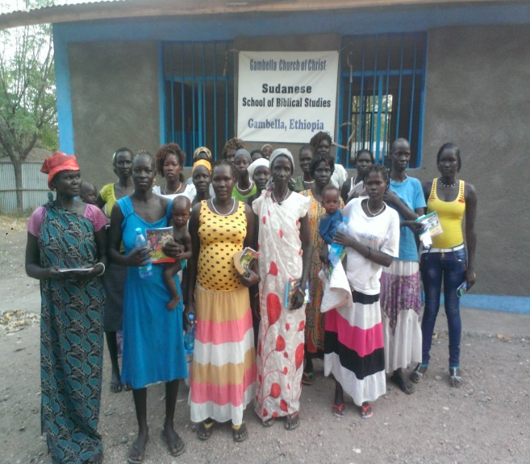
Continued success of the two previous Vacation Bible Schools in Gambella: If you recall from an earlier newsletter, I discussed the hate even unto death of the South Sudanese Anywaa Tribe and the South Sudanese Nuer Tribe. I also wrote about fifty Anywaa children attending our Vacation Bible School with one hundred fifty Nuer children. I also wrote of an Anywaa man, Okello Obang, that lives in Gambella and was converted by a World Bible School Correspondnce Course, who joined our team to teach the gospel to the Anywaa people. Due to the vigorous work of Okello, twelve parents of the Anywaa children that attended the VBS have become Christians. Seven of the new Anywaa sisters joined 25 Nuer sisters to attend a two day seminar as I taught about the woman’s role in the Lord’s Church. What an exciting and special experience. I was able to witness one of the greatest events of the ministry, UNITY IN CHRIST. Christian’s from two tribes that hate each other worshiping and fellowshipping together. WOW! There were also 81 former Vacation Bible School students, Nuer Children, present at the Sunday morning assembly in Gambella.
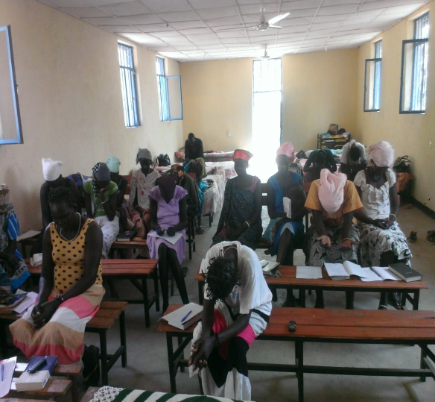
Tyrone with translators and Anywaa & Nuer women praying together
The plans for 2015 are also very exciting. We have added several organized activities at all the congregations to encourage families to fellowship together and with other families, we have added organized activities one day a week for the children, we will continue daily evangelistic and maturing study opportunities, we will have two Vacation Bible Schools, one for 300 Nuer Children and one for 150 Anywaa Children. The two week-long schools will culminate with a UNITED CELEBRATION on the Nuer Compound. We will plan for the students and 75 Nuer Parents and Grandparents and 50 Anywaa Parents and Grandparents to attend the celebration. We will have the annual School of Biblical Studies students spend the entire week after the Vacation Bible School visiting the parents of the VBS students striving to teach them the gospel.
We are currently in the process of attaining land in the Anywaa area for a compound. Upon receiving a deed to the land, we will build a compound to include a church building for the Anywaa brethren and we are praying that the Lord will send us two Ethiopian Preachers so we can start an Ethiopian Congregation in Gambella. There has never been an Ethiopian Congregation in the Gambella, Ethiopia Region. These and other plans will certainly keep us busy in 2015. It is IMPORTANT to note EVERY PLAN is designed to help with the furtherance of the gospel to the glory of Christ, Ephesians 3:21
I am VERY GREATFUL to every church and/or individual that supports this ministry through prayer, encouragement or financially. BE ASSURED AS WE PARTNER TOGETHER, YOU ARE AS IMPORTANT TO THE MISSION AS WE ARE.
Tax deductible contributions may be made payable to Woodland Oaks Church of Christ, ear-marked South Sudan Mission and mailed to Tyrone Mynhier for posting and delivery to Woodland Oaks.

Love in Christ,
Tyrone Mynhier

