SOUTHERN SUDAN MISSION

February 5, 2016
Dear friends and supporters of the Southern Sudan Mission,
I thank God always for you and your fellowship with me in the furtherance of the gospel in South Sudan.
I just returned from teaching and preaching in Gambella (Ethiopia), Juba (South Sudan) and Bor Town (South Sudan). I am always thankful for God’s blessings and for His continual care for me. A few days after I left Gambella, Ethiopia for South Sudan there was an uprising of some Nuer Tribesman against Anywaa Tribesmen at the University in Gambella. A student from one-tribe threw a hand grenade into the dorm of another tribe killing several students. Of course there was quick retaliation which started a tribal war among the students. The governing authorities immediately sent the Ethiopian Military to Gambella to deal with the problem. Whenever the Military intervened, the fighting ceased at the University, but a few students escaped and returned to their villages and continued the fighting. The military confined everyone to their homes, shut down the roads, airport, etc to stop the fighting. Fortunately the Military got things under control, but over 100 students were killed. The Ethiopian Officials do not tolerate such action. In fact the same thing happened at a University in Addis Ababa a few weeks before and the military rushed to the student dorm going room to room throwing those involved out the second, third and fourth story windows.
Potential situations like this can always happen. This is why we decided to build our compound in Gambella, Ethiopia instead of South Sudan. Although there are several South Sudanese Refugee Camps near Gambella and many different South Sudanese Refugees living among the Ethiopians in Gambella, there have been limited problems, none since I have been going. Whenever problems arise, the Ethiopian Government shuts it down quickly.
I know all of this sounds bad and it is, but don’t we experience the same in America? Just be thankful God is in control.
Brother Jacob Agany, works with Dennis Caddy and Chuck Dennis, brethren from Wichita Falls, Texas. The brethren obtained land from the Officials in Bor Town, South Sudan to build a vocational school in 2013. Jacob, a Dinka, the ruling tribe in South Sudan, was one of the first converts in Bor Town.
I was privileged to meet Jacob in 2013 when Dennis and Chuck sent him to Gambella, Ethiopia, to attend the School of Biblical Studies, Level One Class. It was evident Jacob was very dedicated and determined to learn God’s Word as he was one of the top students in the class.
In early 2014, Dennis and Chuck asked me if I would go to Bor Town and teach for a period of time, which I did. The Lord blessed our efforts with several converts. In 2014, Jacob attended our Level Two Class, accompanied by three of the converts attending the Level One Class.
Shortly after Jacob and the three brethren completed their studies and returned to Bor Town, they were all confronted by their families, friends and members of the Presbyterian Church, where they had been leaders in the church. Everyone was angry with Jacob for obeying the gospel and encouraging the others to leave their family religion. Jacob was confronted by his wife, her family and many members of the Presbyterian Church. Finally the Bishop of the church confronted Jacob and told him he must return to the Presbyterian Church or he would be ostracized from the church, lose his wife, family, etc. Jacob remained steadfast to the truth and continued teaching others. Shortly after that problem the rebels, Nuer Tribesman, took over Bor Town and Jacob and his pregnant wife crossed the Nile River and lived in the bush until the United Nations peace keeping force took control of the region.
Jacob returned to Bor Town and continued his work with the church. Chuck and Dennis have given Jacob the responsibility of overseeing all of the work in Bor Town including being the principle of the vocational school. Thankfully after a period of time, Jacob’s wife obeyed the gospel.
Jacob asked Chuck and Dennis to ask me to return to Bor Town in January 2015, to teach many new converts, I refused for two reasons: There was still warfare in the Jongeli Province and I had too many responsibilities in Gambella. They ask if I would go to Bor Town in January 2016 and teach maturing studies to many additional Christian’s, which I agreed.
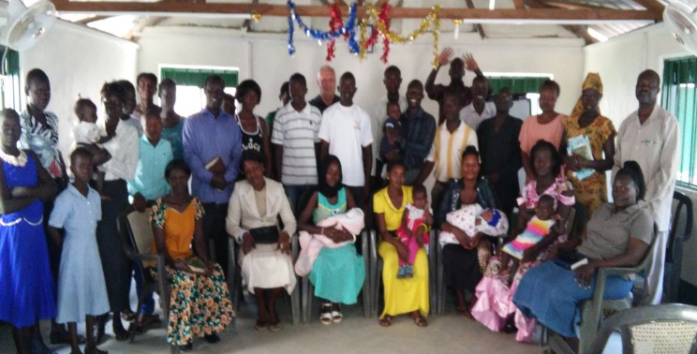
After completing my work in Gambella, I traveled to Bor and spent ten days teaching an average of thirty five students for six hours a day. Due to the former problems in South Sudan, the Bor Airport shut down on weekends and only had a flew flights during the week if there were enough passengers; therefore, Chuck and Dennis encouraged me to travel by land from Bor Town to Juba for fear I might not get to Juba in time to return to Addis Ababa and home as scheduled. It was quite an interesting trip, yes a little dangerous, but I think the greatest danger was the dirt roads we traveled on for hours. Thankfully the Lord delivered me to Juba, the capital of South Sudan. I met with and preached for the church in Juba. Thankfully the flight from Juba, South Sudan departed as scheduled and I arrived in Addis Ababa, Ethiopia on Monday and left for the GREAT USA Tuesday Night arriving Wednesday afternoon December 3rd.
There were many additional successes: Five obeyed the gospel in Bor Town, South Sudan, and another young man told me before I left that he was going to obey the gospel. While in Gambella, we made final preparations for the year: Vacation Bible School in July, the annual School of Biblical Studies in June through September, continuing education classes throughout the year, etc. We also relocated some preachers to work with four seeded congregations, and to teach the new converts as the Lord continues to bless the work in abundance.
As I mentioned in a previous news-letter, Ruach Bol, one of the September, 2015 graduates returned to his home in Lare, Ethiopia, near the South Sudan border, and seeded a congregation baptizing twenty one people into Christ. He continues to teach and many others have obeyed the gospel. He has seeded three additional congregations in neighboring villages and towns close to the South Sudan Border. He has baptized approximately one hundred into Christ, Galatians 3:26-27.
Brother Bol made a request of the government officials for land to build a compound, church building, etc. The officials gave the church ten thousand square meters of land for the same. The brethren as seen here are fencing the land as soon as possible, because people try to take the land. Fortunately the government officials in different areas, where the church has been seeded, have been very gracious and receptive of the Lord’s Church.
As the church expands to new areas, many people in the neighboring towns and villages, having heard we are teaching the Bible, are requesting preachers to come to their town or village to study the Bible with them. Unfortunately, although the requests are great, we do not have enough preachers to meet the need.
I know each of you will rejoice at the following news: The Nuer Congregation, at Newland-Gambella, Ethiopia, (the compound I work out of) are averaging over one hundred children every Lord’s Day, and the Anywaa Congregation in Pwoljay-Gambella, Ethiopia, (the congregation Okello works with) are averaging approximately 90 children every Lord’s Day.
Thanks again for your continued love. Prayers, encouragement and financial support of the Southern Sudan Mission. Please continue to keep this great mission opportunity in your prayers. Also please pray the Lord will provide us a Land Rover Vehicle, cost $40,000, as we now have congregations 100 plus miles from Gambella with limited transportation in the dry season and no transportation in the rainy season.
All tax deductible gifts should be made payable to Woodland Oaks Church of Christ, ear-marked, Southern Sudan Mission and mailed to Woodland Oaks Church of Christ.
Thanks again for your love, prayers and support,
Tyrone Mynhier, Ephesians 3:21

