SOUTHERN SUDAN MISSION

December 1, 2014
Dear Brethren and Friends of the Gospel Outreach to Southern Sudan Mission,
It is hard to believe another year is quickly coming to an end. I am thankful to report God has and is working mightily though His people in the Southern Sudan Mission. Thousands have been taught the gospel and many have obeyed. Several new congregations have been seeded in refugee camps and other locations as well. All have grown numerically and spiritually. Additionally God has richly blessed the mission. Electricity and water have been added to the compound and all of the proposed structures have been completed except the guest house, which is currently under construction.
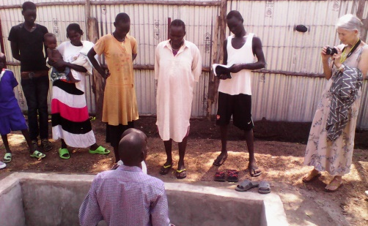
We have many exciting goals for 2015: First, we plan to seed an Ethiopian Congregation at our Nuer Sudanese compound in Gambella. We believe this is very important as the populist in the Gambella Region is half Ethiopian and half Sudanese and there is not an Ethiopian congregation in the region. Although a few Ethiopians have been converted over the years, most are not faithful as we do not have an Ethiopian Preacher to teach them and the Ethiopians do not speak English or the Sudanese dialect. Over the past four years we have dedicated our time and work exclusively with the Sudanese as our goal was to train Sudanese Preachers. With the completion of the structures we have facilities to accommodate the school and both congregations. With this in mind, we plan to add two Ethiopian Preachers to work with the congregation. Second, we plan to add an independent Vacation Bible School in the Anywaa Sudanese area for the Anywaa Sudanese children. Third, remember the children that were turned away from our Vacation Bible School in 2013 and 2014 because we did not have enough teachers? We plan to add teachers to accommodate an additional 100 children at the Nuer Sudanese VBS. This is a great mission opportunity and as stated we need several additional teachers. If you desire to help or seek information about helping please contact Brother Bryce Caldwell, director of the VBS schools, or Tyrone. Commitments must be made by March of 2015. Fourth, we will be working to add an additional twelve week School of Biblical Studies.
If you recall from the October news-letter, Brother Okello Obang, of the Sudanese Anywaa tribe, joined our mission team in Gambella and will work exclusively with the Anywaa Tribesman. Brother Okello has not let any grass grow under his feet. He has located a temporary meeting facility. He also began visiting the parents of the Anywaa Children that attended our recent Vacation Bible School and reports every contact has been very positive. Four people, three women and a man, obeyed the gospel in November 2014. Remember, the Anywaa Tribesmen and the Nuer Tribesmen hate each other? We can rejoice as we witness the unifying power of God’s Word as James Puot, the Nuer Preacher is pictured baptizing the Anywaa into Christ. (The baptisms were in our newly constructed baptistery on the compound. No more crocodiles, snakes, etc. Isn’t that good news)? Okello also has several additional Bible Studies in progress.
Okello has contacted the government officials about a land grant for a compound and church building in the Anywaa area in Gambella. His request prompted the officials to look at the proposed land he has chosen, survey it and began processing paperwork to grant the church a deed for the land. Hopefully we will get a response within the next few months. Please keep all these individuals and efforts in your prayers.
As an important side note; when the Lord blesses us with the Ethiopian Congregation there will be three congregations of the Lord’s Church in Gambella: Sudanese-Anywaa, Sudanese-Nuer, and Ethiopian. Isn’t it amazing how God uses people to accomplish His will? Because of your partnership through prayers, encouragement and financial support, you are as much a part of the Lord’s successes as we are. Thank you! But, we should never forget, God gets the glory.
GOOD NEWS! David Thoatmer graduated from Sunset International Bible Institute, October 10, 2014. He departed for Gambella, Ethiopia where he will be united with his wife. He will be teaching and preaching in the Fugindo Refugee Camp near Gambella. He will also teach in the School of Biblical Studies in Gambella July-September, 2015. David will also translate Bible Courses to the Sudanese Nuer Language. If you would like to help support David, please make your tax deductible checks payable to Woodland Oaks Church of Christ, ear-marked South Sudan Mission/David and mail the same to Tyrone Mynhier and I will post the checks, then deliver them to Woodland Oaks.
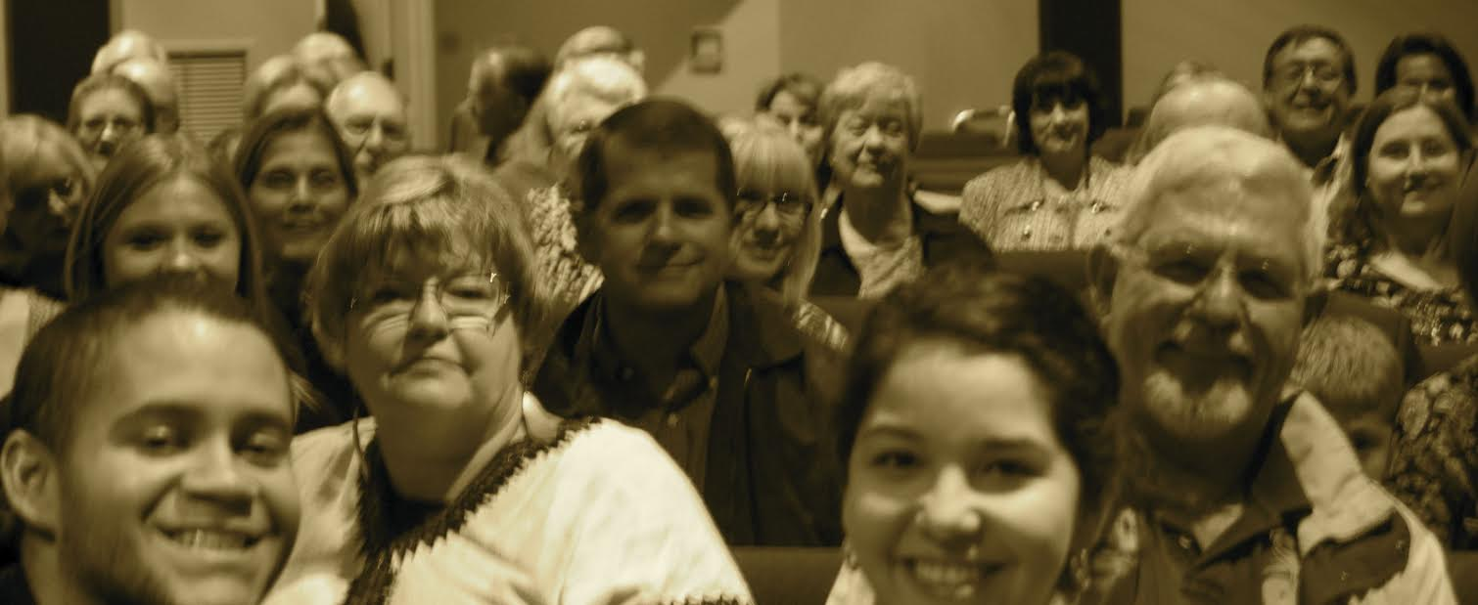
Our first Southern Sudan Mission Appreciation Banquet, November 8th was a tremendous success. Unfortunately some brethren did not get the news concerning the banquet and I apologize for that; however, eighty-five brethren from different congregations attended. There is no way to recognize everyone that helped, but I am deeply grateful for everyone who helped as well as everyone who attended. It is refreshing to know so many brethren have an appreciation and commitment to take the gospel into the world.
I will make my first 2015 mission trip to Gambella, January 14th. I will have the opportunity to meet with the preachers working in the new refugee camps to discuss problems in the camps and teach continuing education classes. I will also review the goals for 2015 with them. I look forward to this and all the opportunities God will bless us with in 2015 to further His kingdom. Again I am deeply grateful to everyone for your trust and partnership to continue this exciting work!
If you are looking for a place to make those last tax deductible contributions for 2014, I pray you will consider this great English Speaking Mission Opportunity.
Please make your tax deductible contributions to Woodland Oaks Church of Christ ear-marked Southern Sudan Mission and mail the same to Tyrone Mynhier for posting. After posting, I will deliver them to Woodland Oaks.
“Now to Him who is able to do immeasurably more than all we ask or imagine, according to his power that is at work within us, to Him be the glory in the church and in Christ Jesus throughout all generations, for ever and ever! Amen.” Ephesians 3:20-21.

Tyrone Mynhier

Alma & I, wish
everyone a very
Happy Holiday
Season and a Prosperous New Year.

