Mission in South Sudan

April 15, 2014
Dear friends and supporters,
There have been dramatic changes in South Sudan since my last newsletter. We are very grateful to the Lord regarding our knowledge that all of the brethren from Malakal and the villages in the Upper Nile Region have made their way through the bush (countryside) to Nisar, South Sudan. Although many arrived sick and others weak from starvation from their 6-8 week trek, they were extremely glad to be greeted by the brethren in Nisar.
If you recall, we are sending money monthly to Nisar, South Sudan to purchase and distribute food to the brethren. We are blessed to have faithful Sudanese Brethren from Gambella, Ethiopia that we can trust to carry the funds on a two day journey by foot and river boat to Nisar. We feel it is important to send the funds with different brethren each month so the rebels along the way do not recognize any of them as regular travelers.
Aside from the problem/privilege stated above, we are excited about several good things that are happening among the South Sudanese brethren in Gambella, Ethiopia, our headquarters for the Southern Sudanese Mission. The church continues to have additions and is growing spiritually. Families are being united in Christ. The number of women in the church has grown considerably and the children’s ministry continues to grow. Additionally the brethren are overwhelmed with the generosity of the American Brethren support in the food efforts.
We are also excited some of the proposed construction has begun. This phase will include adding additional seating to the assembly hall and classrooms to be used for children’s classes and for classes for the School of Biblical Studies. Additional construction will include showers for the students and a male and female dry toilet. We will also reinforce the fence around the compound.
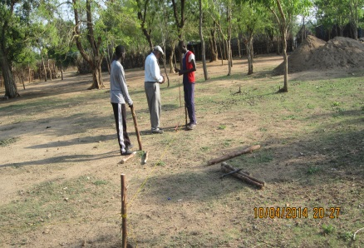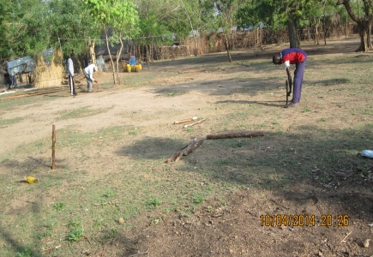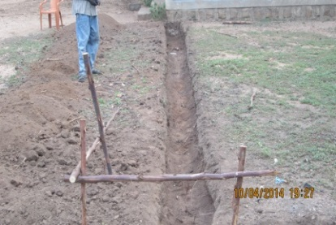
Although we do not have the funds to construct the proposed guest house, we felt it was important to begin the above work with hopes of completing the project before the rainy season sets in. If the Lord blesses us with the additional funds needed to construct the proposed guest house ($35,000), we hope to get it completed before the rainy season also.
I will travel to Gambella May 5th to check on the construction, talk with the preachers about the continued food needs and distribution, encourage the brethren and make final preparations for the upcoming School of Biblical Studies which begins June 23rd and the second annual Vacation Bible School which begins July 29th.
In an earlier newsletter I mentioned a couple we met from Holland, Walther and Elsa. Walther heads up a humanitarian organization, ZOA, in Gambella. He and his employees work extensively training the South Sudanese Refugees throughout Ethiopia. Although they have not become Christians, they have been attending the worship services in Gambella. Several days ago Elsa obtained multiple eye glasses and used our compound to distribute the same to the South Sudanese People. What a wonderful blessing! Additionally all the recipients were introduced to our compound and the church. Isn’t it amazing how God works?
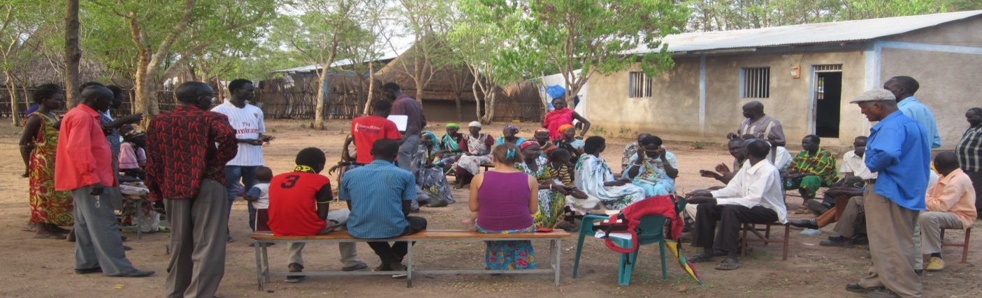
As in all of our mission efforts, we depend on the prayers and financial support of the brethren to make the opportunity possible. Please consider the present urgent financial needs: $5,000 a month to feed the displaced brethren in Nisar, South Sudan, $30,000.00 for additional construction and $4,000 for the proposed May trip.
If you can help financially for any amount it would be extremely helpful.
Tax deductible contributions may be made payable to Woodland Oaks Church of Christ, ear-marked South Sudan Mission and mailed to Tyrone Mynhier for posting. After posting Tyrone will deliver the same to Woodland Oaks.
Please pass this information to your friends and/or any congregations you think might be interested in knowing more about this great English speaking evangelistic opportunity.
Thank you so much for your partnership with me in the furtherance of the gospel. I pray I will always be faithful to the Lord and to you.
Because of Calvary,
Tyrone Mynhier

