SOUTHERN SUDAN MISSION
532 Raleigh Dr.
Conroe, Texas 77302
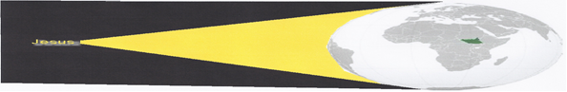
SHINING THE “LIGHT” INTO SOUTH SUDA
www.missioninsouthernsudan.com
EIN 81-1577318
September 1, 2019

Dear friends and supporters of Southern Sudan Mission. I pray God’s riches blessing be on you.

January 2013, in search of recognition and acceptance of the Lord’s Church in Gambella, Ethiopia, we decided to have a Vacation Bible School. Although that part of Africa had never had one, we thought it could and should be done. With that goal in mind we asked several Ladies to go and teach. Our request was met by Joanie Roberts and three other Christian ladies resulting in the first Vacation Bible School in Ethiopia. The Vacation Bible School, which is one of the most productive works in the Mission, has been tremendously successful having taught 8,100 children,.

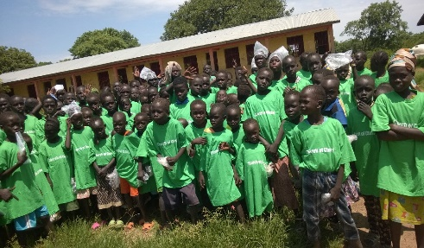
This year as the mission team, 23 teachers, were teaching 3,200 children they also taught 4 South Sudanese Women from 4 different refugee camps to teach. Upon returning to their camp July 27th, the 4 women taught additional women to teach increasing the number to 4 teachers and 4 helpers. The following four weeks the Sudanese Teachers and their helpers taught 800 Sundanese Children in 3 different refugee camps. The total number of children taught this year is 4,000. The total taught in the past 7 years is 8,100 children.

It is important to know, no one other than a United Nation worker, refugee, an individual with government clearance, etc. is permitted to enter a refugee camp. For this reason, all the previous Vacation Bible School opportunities have been with refugees in towns and villages in the Gambella Region. For this reason the success of training the Sudanese Women and their ability to teach has opened additional doors: 1) the trained teachers are prepared to also teach the children in Bible class on Sundays and Wednesdays; 2) it opens the door to teaching in the 6 refugee camps in the Gambella Region which have multiple divisions in each camp totaling 25 plus divisions; 3) we will train additional teachers each year until we have trained an adequate number to teach in all the refugee camps. FRUIT FOR THOUGHT: When we staff all the divisions of the refugee camps, 25 plus and teach a minimum of 1,000 children a year in each camp that totals 25,000 children plus the American teachers teaching 5,000 plus a year totals 30,000 children a year. I KNOW, OLE TYRONE IS A CRAZY DREAMER! Bye the way, when I first mentioned a Vacation Bible School in Gambella, Ethiopia in 2013 many people thought it was a crazy stupid idea. Well 7 years latter 8,100 South Sudanese Children have had the opportunity to learn about Jesus being taught by 60 plus teachers from the states. To God be glory. Never forget, if God takes you to it, He will take you through it! “Everything is possible for him who believes,” Mark 9:23
Additional blessings! Many of you know l had emergency pacemaker implant surgery and could not return to Gambella to teach the final session and will not be there to witness the graduation of 27 students September 13th. Thankfully Brother Jim Chandler, an elder from Portales NM, and a fellow teacher, went without me. In a conversation I had with Jim via telephone he said everything was going very well and the students were doing very good in class. He also said he visited the mission’s agriculture site in Lare and the corn crop was looking great. He said if things continue as needed the yield should be 100 plus bushels of corn per acre totaling 1,000 plus bushels. What a blessing! The mission, with your support, has been sending several thousand dollars’ worth of corn to our starving Brethren in the bush in South Sudan for the past several months. When the corn is harvested, we plan to send most of the crop to the Brethren which will help the mission financially as well.

Pictured is Jacob Nhail. Jacob is a converted denonational preacher. He is also a former team member. Upon his conversion he entered the School of Biblical Studies and completed the same. After graduation he preached in the JEWI Refugee Camp for a few years. He decided to attend the University in Gambella and resigned as a preacher. Upon earning his degree, he expressed his desire to work with the mission again and we were excited to accept him back. Jacob is a great soul winner. His primary work will be at the university. He will be responsible for our World Bible School Program located on the campus, conducting Bible Studies with students and teaching Bible classes two nights a week.

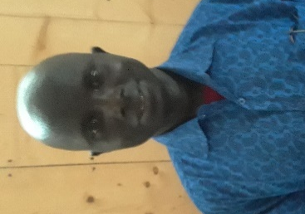
Pictured is Brother Simon Chankuoth. Simon is a new member of the mission team. He is a graduate of the School of Biblical Studies and has a degree in English. He previously worked with the Brethren at the School of Biblical Studies in the Pojack, South Sudan, which was overtaken by the rebels. Simon and the brethren had to flee to refugee camps. Simon, originally from Gambella desired to live and work near his relatives approached us about working with the mission. Fortunately, there was a need for additional workers, and we invited him to work with the mission. He was an asset as an interpreter for the VBS team while getting acquainted with the other works of the mission. In addition to Simon teaching in the school we plan to utilize his degree in English, by offering free learning to speak English opportunities to the Sudanese and Ethiopians. His textbook will be the Bible. This will provide people the opportunity to learn about God as they learn to speak English. The course will be similar to Oklahoma Christian Colleges, “Let’s Start Talking,” which is a very successful evangelistic tool.

We give all the credit regarding the success of the mission to the Lord who continues to bless the mission abundantly.

As the mission grows the need for additional finances grow as well. Please consider partnering with us as we strive to take the gospel to the South Sudanese and the world. You may make your tax-deductible checks payable to Southern Sudan Mission; to Porter Church of Christ ear-marked Southern Sudan Mission and mail the same to Tyrone Mynhier 532 Raleigh Dr. Conroe, TX 77302 for posting; or contribute through PAYPAL. To contribute through Pay Pal go to the mission website www.missioninsouthernsudan.com and click on Pay Pal.

KEEP THE DATE! KEEP THE DATE! KEEP THE DATE!

Friday November 15, 2019

ANNUAL SOUTHERN SUDAN MISSION BENEFIT

