SOUTHERN SUDAN MISSION 532 Raleigh Dr. Conroe, Texas 77302
Shining the “LIGHT” into South Sudan
July 18, 2018
Dear friends and supporters of the Southern Sudan Mission.
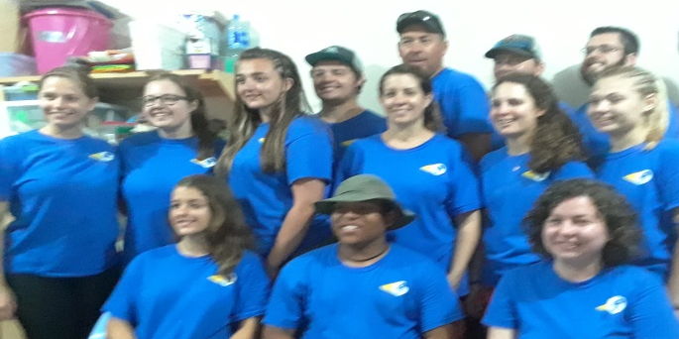
Thanks to the Lord and the Southern Sudan Mission Vacation Bible School Team, 1800 South Sudanese Refugee Children living in the Gambella Region, of Ethiopia were taught the miracles of Jesus. The members of the team were from four different congregations: Kensett Church of Christ, Kensett, AR; Mountain Home Church of Christ, Mountain Home, AR; Portales Valley Church of Christ, Portales, New Mexico; and Woodland Oaks Church of Christ, The Woodlands, TX. Brother Cheston Hoople of Woodland Oaks was scheduled to work with the team, but had to cancel the day before the departure due to his grandmother’s illness and death. Our prayers were and continue to be with the Hoople Family.
Second week teachers: Bottom row left to right: Karisa Holland, Holly Chandler, Sarah Mayo, Tammy Chandler
Top row left to right: Nathan Lockwood, team leader, Colin Chandler, Dyllon Chandler and Tanner Gibson.

First week teachers: Bottom row left to right: Holly Chandler, David Martinez, Kaytlin Gonzales
Middle row left to right: Karisa Holland, Grace Lance, Daizia Looney, Tammy Chandler, Sarah Mayo, Sarah Fleming
Top row left to right: Colin Chandler, Dyllon Chandler, & Bryce Caldwell: Team Leader

If you recall the genesis of the Vacation Bible School in 2013, Joanie Roberts, director, accompanied by Karisa Holland, Rusty Holland and Alma Mynhier served several purposes:
- The mission was relatively new having started in Gambella in 2011 as a School of Preaching to train South Sudanese Preachers.
- When the students began teaching their relatives and friends, most rejected the gospel and their sons for attending the school and teaching the gospel.
- The church leaders in Gambella asked us to stop teaching the Bible because several of their members had obeyed the gospel and left their congregations.
- Upon our telling the parents and church leaders we must teach the gospel as Jesus commissioned, Mark 16:15-16, those who rejected the teaching and the school began accusing the mission of being a divisive mission and work of the Devil.
- After much prayer and seeking a solution to the problem the mission leaders decided to have a Vacation Bible School.
- At the conclusion of the first Vacation Bible School the parents were invited to attend the celebration and they were ecstatic to see and hear what their children had learned about the Bible.
- The parents praised the teachers and asked them to please return and teach their children. Every VBS since has increased in number and the appreciation and receptivity of the church has grown greatly. (4,100 children have been taught to date!)

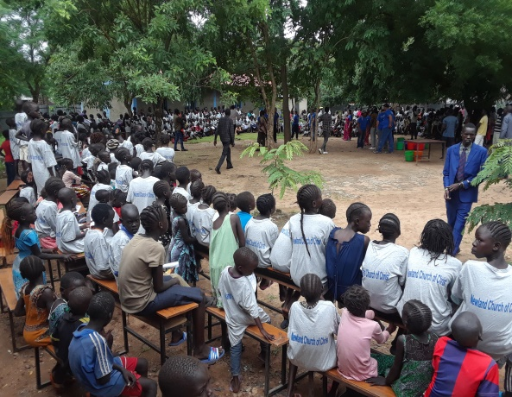
Hundreds of children and parents at the VBS celebration

That being said, last year, the VBS team taught 300 students in a city near Gambella, called Lare. The teachings were received warmly; however, when the team went to teach at Lare this year they met adversity from two religious groups: The Seven Day Adventist and the Assembly of God. When the religious leaders of these churches learned the VBS team had returned to teach 600 children they were very upset. They went to the city authorities proclaiming the VBS team was the anti-Christ, the Illuminati, a secret society conspiracy and false teachers. The leaders requested the authorities stop the VBS for the sake of the city and the children. The city authorities approached the preachers and leaders of the Lare Church about the accusations. When the Lare Church leaders presented Ethiopian Government Documentation that the Church of Christ was a legal registered and approved church, the authorities dismissed all charges and the VBS continued. Additionally, at the VBS concluding celebration last year, the mission team served the children and parents popcorn and pink lemonade. Realizing there would be a celebration at the conclusion of this year’s VBS, the Adventist and Assembly of God church leaders told the people the lemonade was poisonous and would kill the children. Unfortunately some of the parents took their children out of VBS and would not let them return; however, they were replaced as there were several hundred other children wanting to attend.
Since the all-powerful God always wins, the failed attempt to stop the VBS became a victory. The parents of the Lare Church and many other parents asked the Lare church leaders to teach them about false teachers, which will open the door to teach the gospel to many.
Additionally, it needs to be mentioned; as most of you know, the mission team really struggled giving t-shirts this year due to the number of students and the cost of each shirt; however, we made a plea to you supporters and enough money was raised to purchase the shirts. JUST THINK! The mission team gave t-shirts, with Lare Church of Christ inscribed on them to 600 children and 35 workers that will be proudly worn by each individual several times a week if not daily.
It is important to note there was never a physical treat to the church leaders or VBS Teachers.
The School of Biblical Studies also began June 25th. Since we only have beds for 20 students in the dorm we prefer to keep the enrollment at 20; however, with the continual addition of new congregations and a shortage of preachers we permitted 37 students to enroll. To date we have graduated over 300 preachers, many of which are being supported as full time preachers.
Good News! The mission has several acres of corn planted on one farm and in several compounds. When Brother Colin Chandler, an elder from the Portales Church of Christ (also one of the VBS team members) and an experienced farmer farming approximately 10,000 acres of corn in New Mexico, saw the corn, he said if it continued to grow it should produce around 35-40 bushels of corn an acre. He also explained some dos and don’ts about planting corn next year to get a yield of 80 to 100 bushels. Please pray the corn will produce a good harvest so we can send it to the brethren in the bush (brethren hidden from the rebels in the forest) in South Sudan.
GOOD NEWS! President Trump is really pressuring the President of South Sudan to stop leading the tribal war which started in December 2013. The South Sudanese President is from the Dinka tribe and desires to make all other tribes, 60 plus tribes, surrender to the authority of the Dinkas. The tribal war he started has resulted in thousands of deaths and millions of South Sudanese being forced to refugee camps for safety. Due to President Trump’s sanctions and continued threats of more sanctions, the South Sudanese President has begun talking about a peace treaty making all tribesmen equal. Secretary of State, Nicky Hailey, visited one of the refugee camps in Gambella and left weeping bitterly. She said she had never seen people mistreated the way the South Sudanese Refugees were in the camps.
If and when, the South Sudanese Nation becomes a peaceful nation (and it will) we have hundreds of trained preachers and thousands of maturing Christians who will return to their homeland and start congregations throughout South Sudan.
A special thank you for your continued love, prayers, trust, encouragement and financial support. Be assured every supporter of the Southern Sudan Mission is as much a part of the blessings of the work as those of us who are privileged to go.
If you would like to support the mission you may make your tax deductible checks to Porter Church of Christ and mail the same to Tyrone Mynhier, 532 Raleigh Dr. Conroe, TX 77302 for posting and delivery to Porter Church of Christ.
“To Him be glory in the church and in Christ Jesus.” Ephesians 3:21
Tyrone Mynhier

